Meeting and events booking form and information pack
Full name* |  |  | Company (if applicable)
Phone number* |  |  | Email address for invoicing*
Postal address*
Registered charity number to receive 10% discount
Occasion/reason for hire*
Proposed hire date* (dd/mm/yy) |  |  | Number of participants* (approx. no. if not confirmed)
Running times of events (including set up and pack up time) |  |  |  | Start time* |  |  | End time*
Weekdays 9.00am - 5.00pm (min 3 hours)
Sundays 10.00am - 4.00pm (min 3 hours)
Will You require any of the following?
Projector ☐ |  | Speakers ☐ |  |  | Flipchart (please bring own paper) ☐
Any additional questions/comments/requirements?
I have read and understand the roles and responsibilities set out below* |  |  |  |  |  | Yes ☐
Please complete the following form in order to make a booking at the Centre for Wildlife Gardening. All items marked with * are required, and the booking cannot be completed unless filled out. Email completed forms to amarch@wildlondon.org.uk.

Hire Times and Fees
- Meetings: Monday-Friday, 9.00am-5.30pm (including set up and pack up time, min 3 hours)
Sunday, 10.00am-5.00pm (including set up and pack up time, min 3 hours)
The hire fee for the facility is £30 (+VAT) per hour (minimum of three hours). You will be invoiced shortly after booking – please pay within 30 days as specified on invoice.
Discounts:
- We can offer a 20% discount to RSWT and other Wildlife Trusts.
- We can offer a 10% discounts to registered charities.
- Our Corporate Partners (‘Investors in Wildlife’) will receive a 10% discount Subject to availability.
Note: school visits and other LWT activities have priority, there is more availability on weekdays during the winter.

Facilities
- Exclusive use of the classroom (the outside areas remain open to the public)
- Use of the small kitchen facilities (shared with staff) – please bring own tea, coffee, biscuits etc.
- Outside toilets with disabled access and baby changing facilities
- Meeting facilities (WiFi, overhead projector, white board, speakers, flipchart – please bring your own paper) and configurable furniture.
- Suitable for meetings, training events and team building days.
Capacity
Meetings: 20 seated around tables, 40 conference style (tables moved to the side)
Because we are a nature reserve there are a few site rules to be aware of before deciding if Centre for Wildlife Gardening is right for your meeting or event.
Roles and responsibilities
The Centre for Wildlife Gardening is seen as the ‘provider’ and the group making the booking is seen as the ‘user’. Both ‘provider’ and ‘user’ have roles and responsibilities whilst on the nature reserve, these roles and responsibilities are outlined below.
As the ‘provider’ we will:  - Offer the sole use of the classroom for hire  - Offer guidance for preparation and follow-up to the visit e.g. payment, hours etc.  - Facilitate the use of the classroom  - Take a level of responsibility for the group by briefing the leaders on health and safety on the site, briefing the leaders on the use of the classroom and site, and being the ‘go-to’ facilitators for the session. | As the ‘user’ you will:  - Ensure that agreed times are adhered to (times booked include set up and pack up time)  - Ensure that payment is made according to terms of the invoice  - Use the classroom and site responsibly, being aware of the site as a nature reserve and so being sensitive to the site’s needs (e.g. no bouncy castles, no traveling zoos, no fireworks, ask if unsure)  - Be fully responsible for your group’s safety and behaviour prior to and after the session, and at all times whilst on site  - Take all refuse from your event off site  - Ensure the majority of the event (food, music etc.) is held in the classroom  - Ensure any outdoor activity does not disrupt the enjoyment of the space for other visitors and our neighbours  - Leave the classroom and site as it was before the event
Please note, the following are not permitted at Centre for Wildlife Gardening
- Alcohol
- Balloons, piñatas, glitter or small plastic decorations
- Dogs (except assistance dogs)
- Smoking

Location and Transport
Address: The Centre for Wildlife Gardening, 28 Marsden Road, London, SE15 4EE
By Train: Nearest stations are East Dulwich (approx. 0.4 miles away) and Peckham Rye (approx. 0.6 miles away). See map for locations relative to the Centre for Wildlife Gardening.
By Bus: Nearest bus stops are Elsie Road, Ondine Road, East Dulwich Road Goose Green (Stop H) and East Dulwich Road Goose Green (Stop G). See map for locations relative to the Centre for Wildlife Gardening and bus numbers.
By Bike: Please ask a staff member and they will show you where bikes can be safely parked.
By Car: There is free street parking on Marsden Road and surrounding roads but no public parking inside the gates

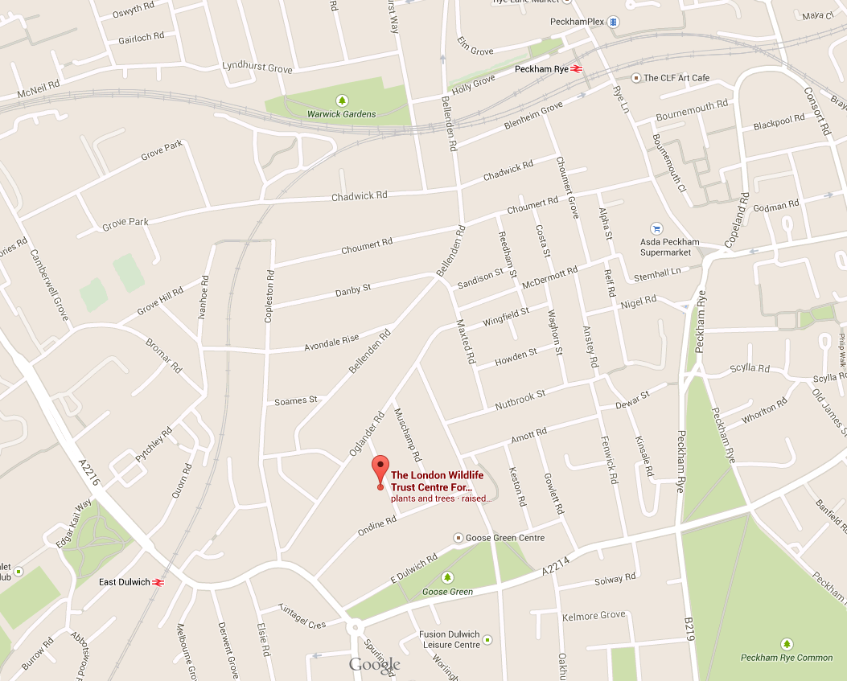
.
Ondine Rd (Stop F) 40, 176, 185, 484, P13
Elsie Rd (Stop A) 40, 176, 185, 484, P13
East Dulwich Rd Goose Green (Stop H) 37, 484
East Dulwich Rd Goose Green (Stop G) 37, 484

